**SET 2-MODEL EXAM -DSA0163C++**

**HARI PRASAD S (192221111)**



**1.write a program to read in a character and determine if it is a vowel or consonant**

**Input:**

#include<iostream>

using namespace std;

int main()

{

char c;

cout<<"enter the charatcter:";

cin>>c;

if( c=='a'||c=='e'||c=='i'||c=='o'||c=='u')

{

cout<<"it is a vowel"<<endl;

}

else if(c=='A'||c=='E'||c=='I'||c=='O'||c=='U')

{

cout<<"it is a vowel"<<endl;

}

else

{

cout<<"it is a consonant";

}

}

**Output:**

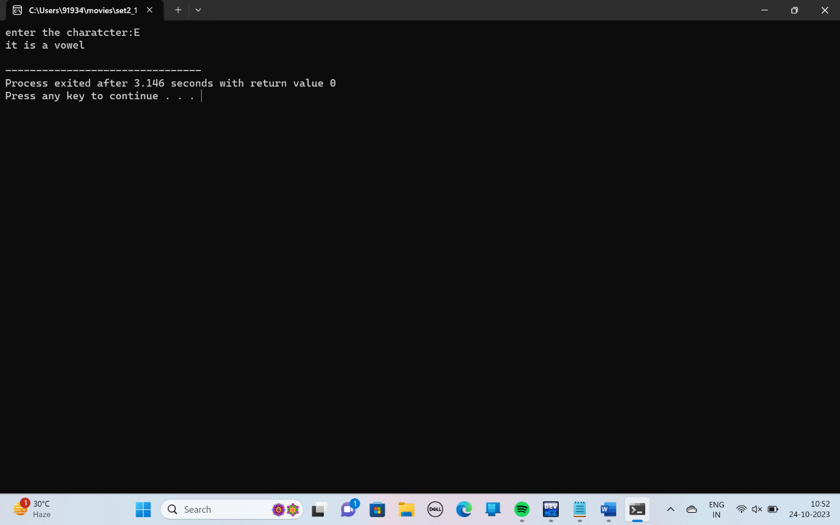

**2.write a program to read in an interger and determine if it is an armstrong number or not**

**Input:**

**#include<iostream>**

**using namespace std;**

**int main()**

**{**

**int n,t,rem,arm=0;**

**cout<<"enter the value of n:";**

**cin>>n;**

**t=n;**

**while(n>0)**

**{**

**rem=n%10;**

**arm=(rem*rem*rem)+arm;**

**n=n/10;**

**}**

**if(t==arm)**

**{**

**cout<<"it is armstrong number";**

**}**

**else**

**{**

**cout<<" not a armstrong number";**

**}**

**}**

**Output:**

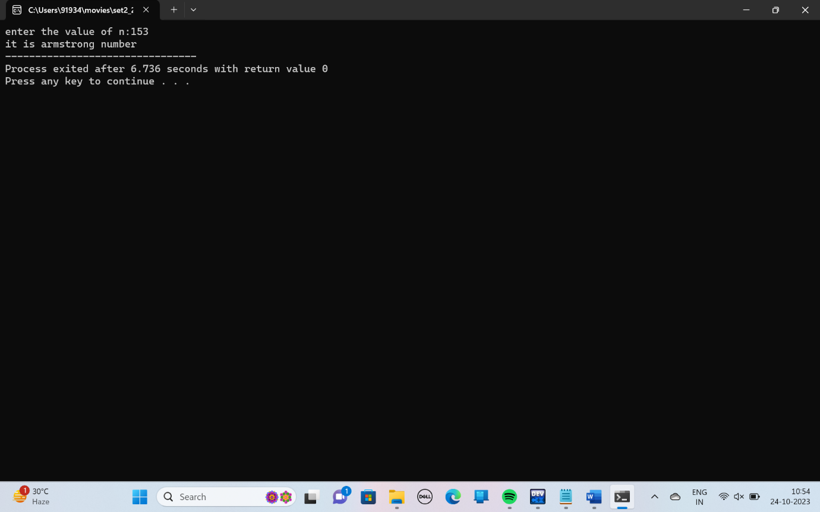

**3.write a program to print the following parttern using nested for loops**

**1**

**22**

**333**

**4444**

**55555**

**Input:**

**#include<iostream>**

**using namespace std;**

**int main()**

**{**

**int n,i,j;**

**cout<<"enter the number:";**

**cin>>n;**

**for(i=1;i<=n;i++)**

**{**

**for(j=1;j<=i;j++)**

**{**

**cout<<i;**

**}**

**cout<<"\n";**

**}**

**}**

**Output:**

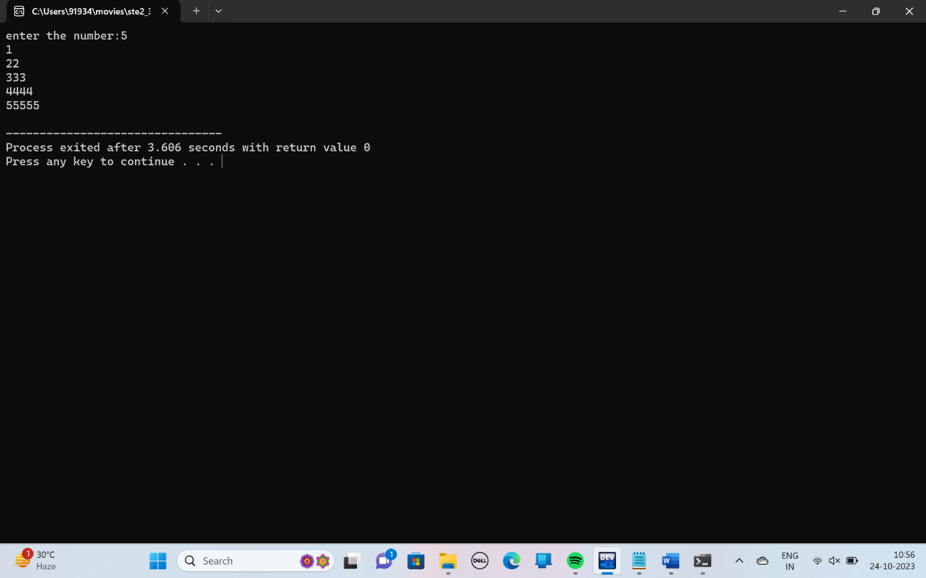

**4.write a c++ program to find the number of occuarance of a value in an array**

**Input:**

**#include <iostream>**

**using namespace std;**

**int main()**

**{**

**int n,value,count=0,arr[n],i;**

**cout <<"Enter the size of the array: ";**

**cin>>n;**

**cout<<"Enter the elements of the array:" <<endl;**

**for (i=0;i<n;i++)**

**{**

**cin>>arr[i];**

**}**

**cout<<"Enter the value to find: ";**

**cin>>value;**

**for(i=0;i<n;i++)**

**{**

**if(arr[i]==value)**

**{**

**count++;**

**}**

**}**

**cout<<"The number of occurrences of "<< value <<"in the array is: "<<count<<endl;**

**}**

**Output:**

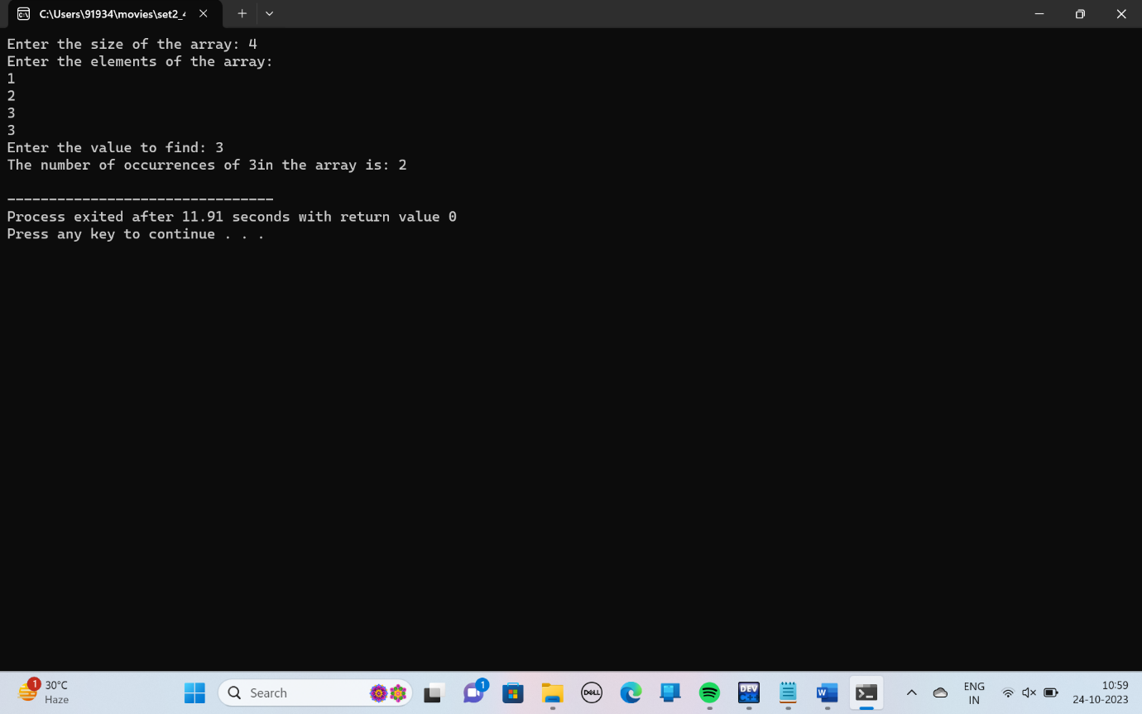

**7.write a c++ program to create ato overload the ++operator to increment a variable.**

**Intput:**

**#include<iostream>**

**using namespace std;**

**class A**

**{**

**public:**

**int a;**

**A operator++(int)**

**{**

**A temp;**

**temp.a=a++;**

**return temp;**

**}**

**};**

**int main()**

**{**

**A A1,A2;**

**A1.a=10;**

**A2=A1++;**

**cout<<A2.a<<endl;**

**cout<<A1.a;**

**}**

**Output:**

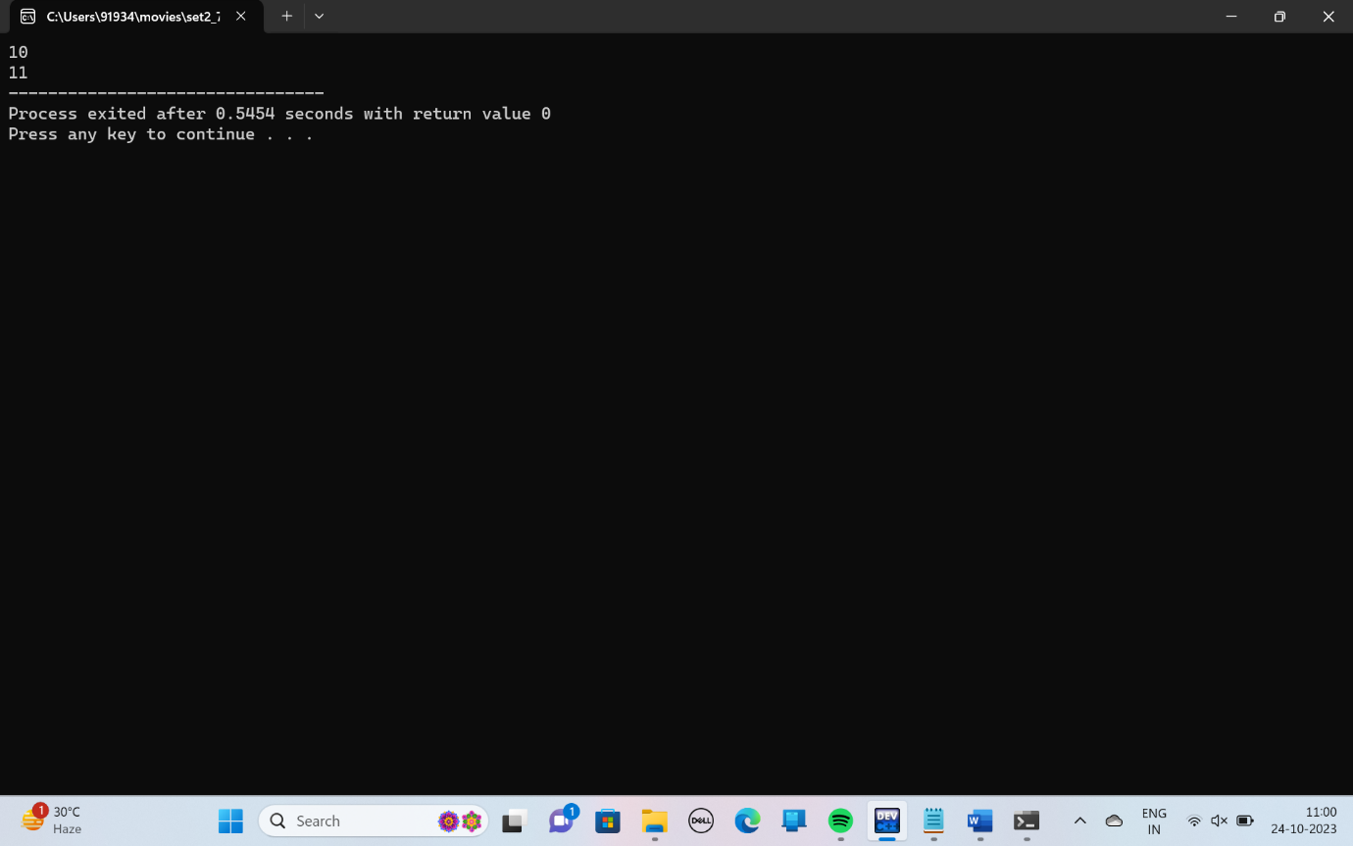

**8.write a c++ program to create a pointer to a fuction and call the function using the pointer**

**Input:**

**#include <iostream>**

**using namespace std;**

**int addition(int a,int b)**

**{**

**return a+b;**

**}**

**int main()**

**{**

**int (*function)(int a, int b);**

**function=addition;**

**int result=function(5,3);**

**cout<<result<<endl;**

**}**

**Output:**

